July 2016 Western Dressage Report

August-September events have been sent to Horse Around NM.
I have sent the arena deposit check and paperwork to Dawn for the Western Dressage day, Sept. 8th, for this year’s NM State Fair. There are details that still need to be worked out in terms of pick-up and building the court at Expo.
Fiesta de Western Dressage at 4 Winds was a blast! Because I was able to go to the 4 Winds trainer’s showcase weekend and talk with loads of interested people the riding spots were taken before the 1st of June.
As always, Sandy Perez Welch did a GREAT job of teaching.
I have spoken to some of the breed associations from New Mexico that are interested in holding Western Dressage events. This could mean more rentals for the court and income for NMDA.
However it could also mean that more people would be riding with the breed clubs than showing with NMDA.
The only advantage for a WD rider being a member of NMDA is the chance to win year end awards and have a reduced rate for showing their horses. The negative side is that WD riders end up supporting the USDF (instead of the USEF that recognizes western dressage). The USDF listing has personally caused me hours of phone calls to get off inappropriate mailing lists. That would be catalogues…mostly….selling equipment that I don’t need nor am not going to buy.
Not much here applies to Western Dressage: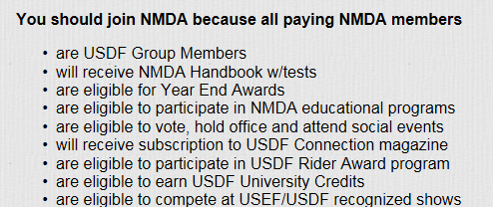
I think it is important for WD riders to continue to support NMDA however and I would appreciate the board considering that WD riders won’t have to join to receive the discount show entry. WD riders would pay a $10 non-member fee (instead of the $20) per entry when we include a copy of our WDAA membership card at the time of entering the show.
Understanding that the reason why many shows were dropped from our awards program I would ask that the NMDA include the NM State Fair Western Dressage day for the awards program. I will be able to get the results very quickly as the management firm for the show tallies that information at the show. I will personally take responsibility for getting the results quickly.
I had requested this in an earlier report this year however it was never discussed.

